

Internship Domain:
Linux Fundamentals Tasks & Instructions
Name:
Muhammad Yaseen
Student ID:
CI/DEC111

Linux Fundamentals Internship

Internship Task Submission Report

TASK 1: Basic Linux Commands Documentation

Objective
To understand and practice essential Linux commands related to file navigation, file operations, system information, and package management.

1. File Navigation Commands
Commands used:
- Pwd
- Ls
- Cd
- tree
Explanation:
- pwd shows the current working directory.
- ls lists files and directories.
- cd changes the directory.
- tree displays directory structure in a tree format.
Screenshot 1:
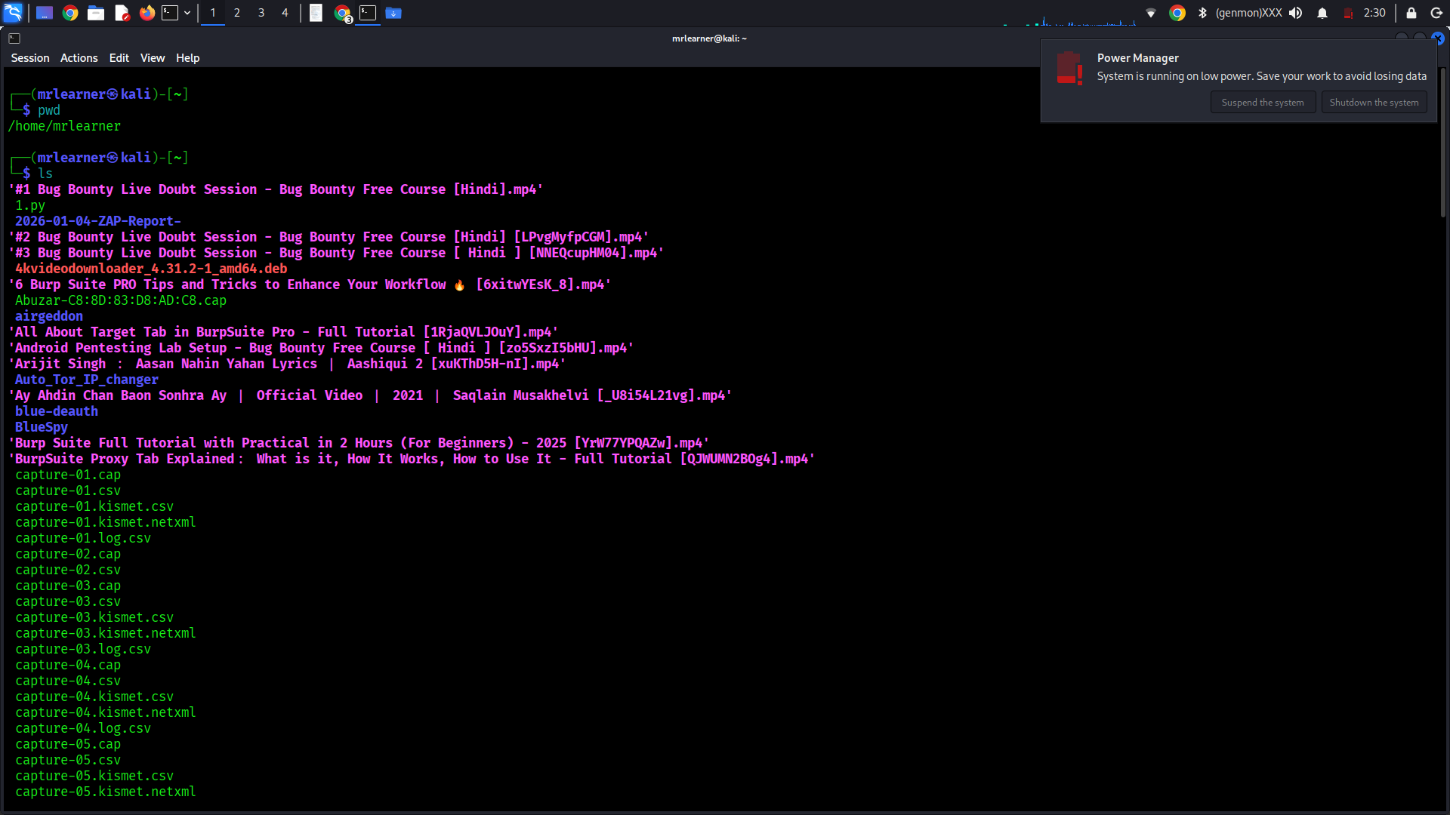

Screenshot 2:
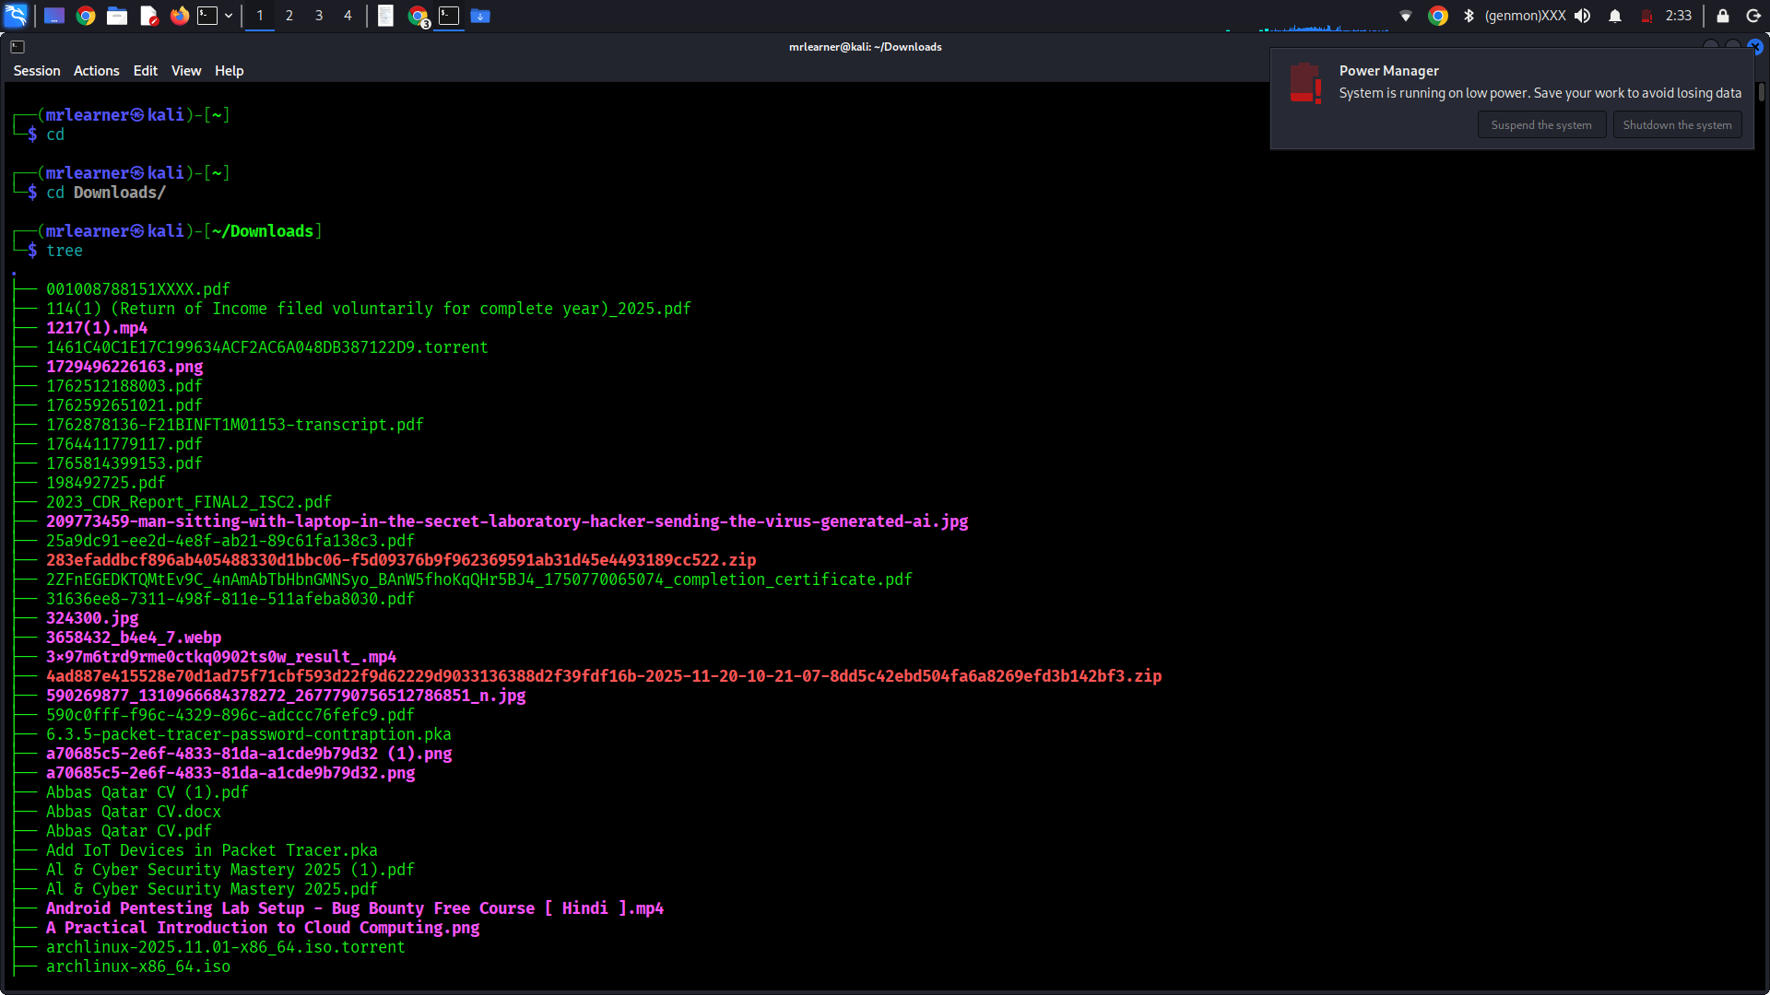
Screenshot 3:
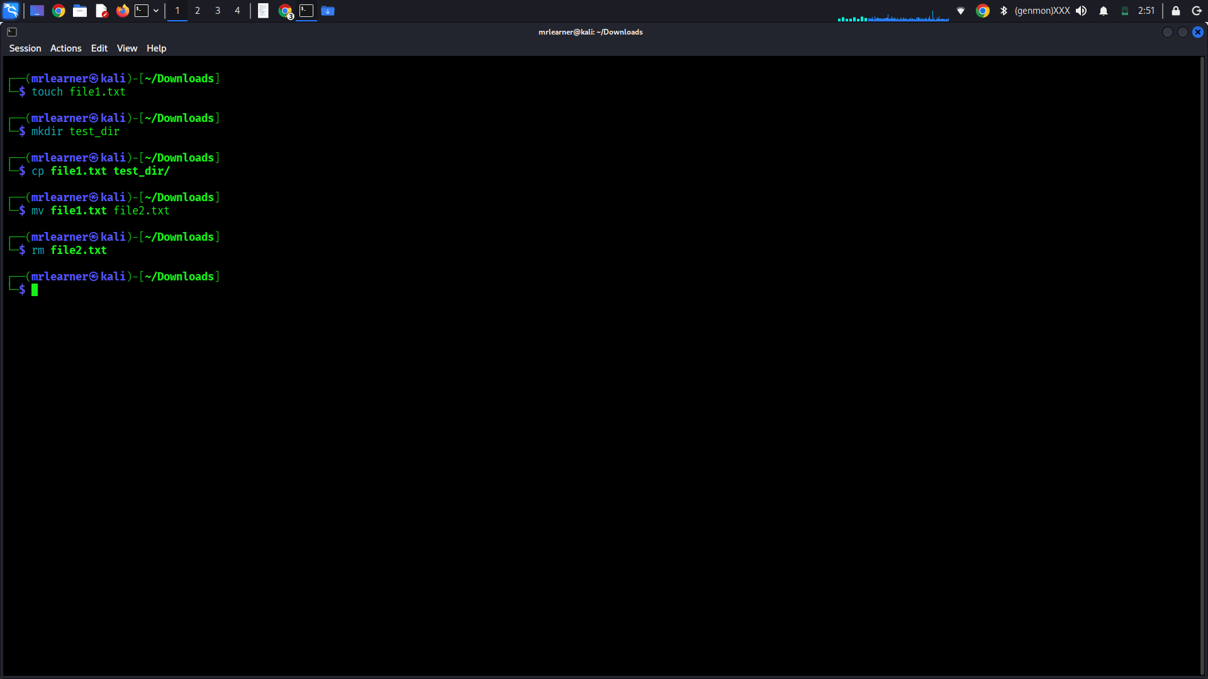

2. File Operations
Commands used:
- touch file1.txt
- mkdir test_dir
- cp file1.txt test_dir/
- mv file1.txt file2.txt
- rm file2.txt
Explanation:
These commands are used to create, copy, move, rename, and delete files and directories.
3. Viewing File Content
Commands used:
- cat /etc/passwd
- head /etc/passwd
- tail /etc/passwd
- less /etc/passwd
Screenshot 4:
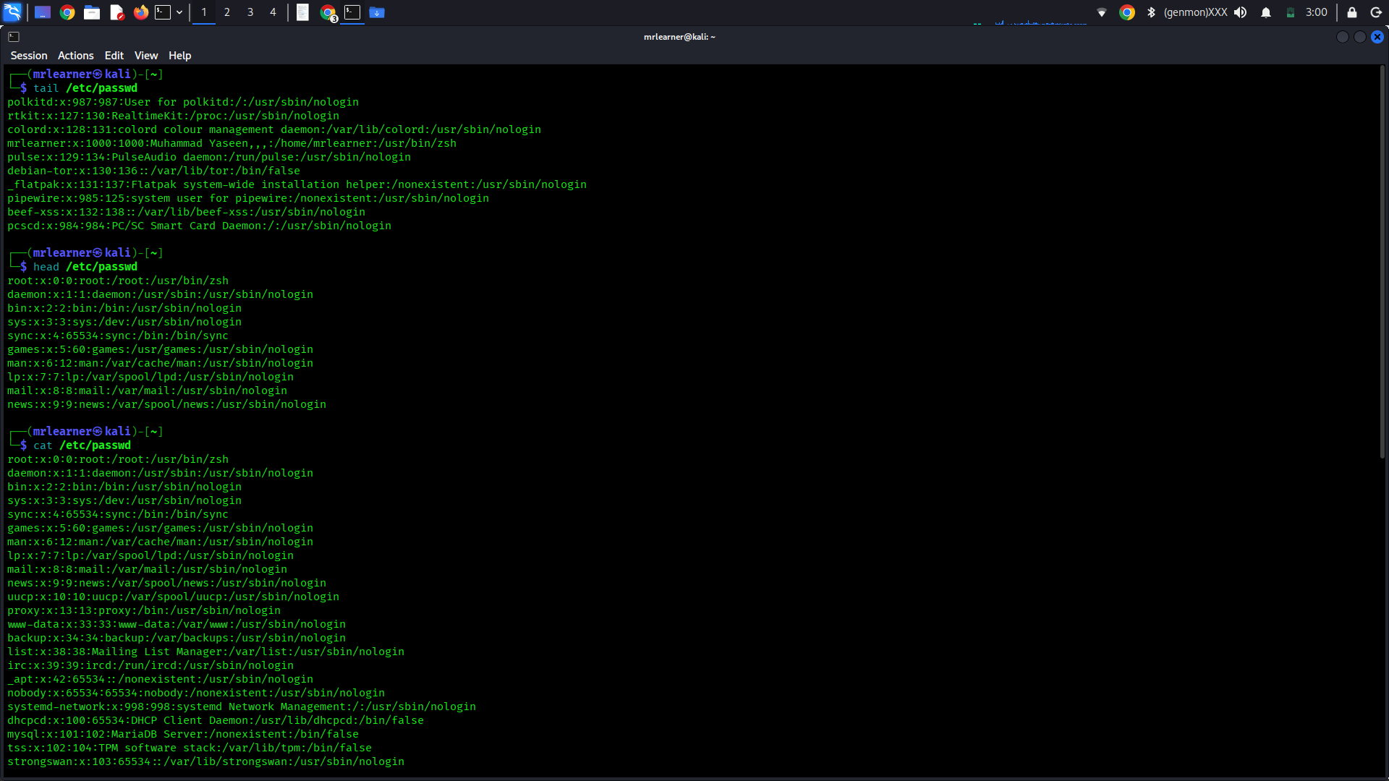
4. Package Management
Commands used:
- sudo apt update
- sudo apt install tree

Screenshot 5:
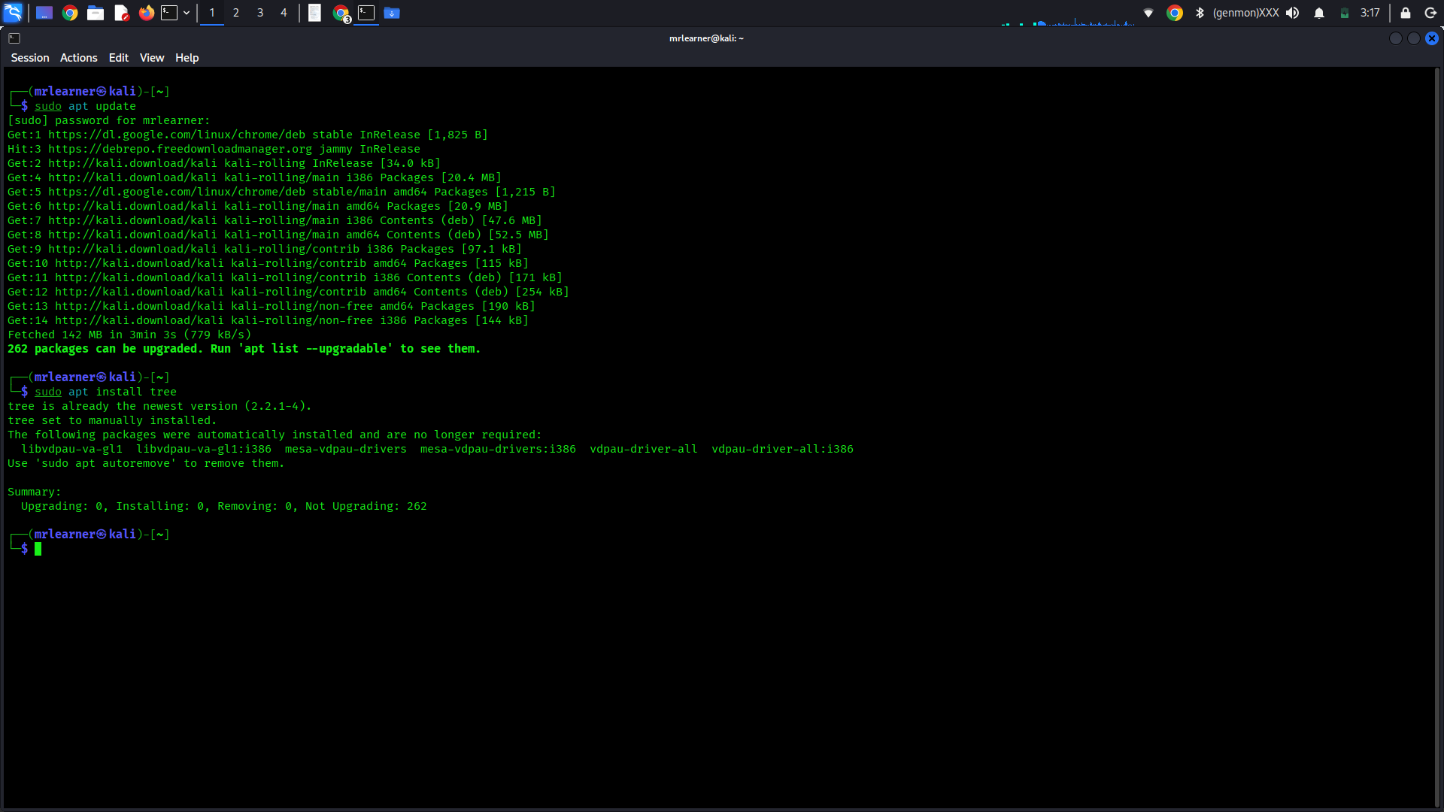
5. System Information
Commands used:
- uname -a
- whoami
- df -h
- free -m

Screenshot 6:
